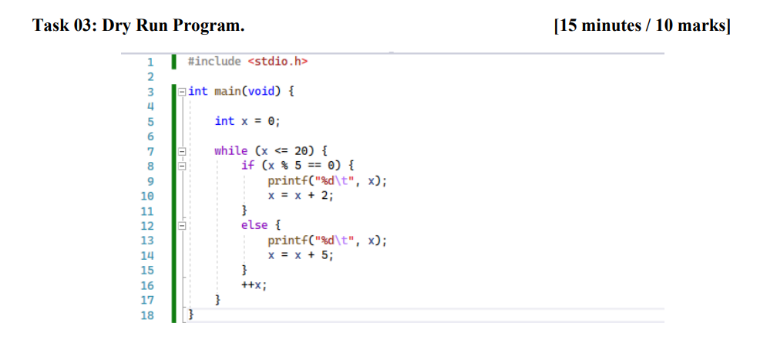

Dry Run:
X= | Output
1 | 1 7 13 19
3 | 3 9 15 18
10 | 10 13 19

